Player Abilities

**NOTE: All numbers written in red should be exposed for tweaking at the testing phase**

# Player Cards

**The player will engage in combat through the use of cards played from their hand. This document will detail those cards and their effect.**

* Utilising the following video to construct a loot table with easily adjustable values this document will refer to each key’s value as its draw frequency.
  + [**https://www.youtube.com/watch?v=_jWxH-rVmTA**](https://www.youtube.com/watch?v=_jWxH-rVmTA)

## Basic Cards

**These will be high priority cards that should draw frequently from the players deck into their hand.**

### Attack

* 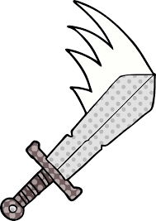The Attack card will have the design of a sword swinging on it.
* This card has the following information on it displayed to the player:
  + Mana Cost – **1**
  + Card Rarity – Common
  + Description – Slash at a target creature
* The draw frequency for this card is **10.**
* When cast:
  + The player should be prompted via UI pop up to “select a target.”
  + When the player hovers their mouse over an enemy they should be outlined with a white line
  + When the player presses LMB, **3** damage should be dealt to the target enemy’s health.
  + A slashing VFX should display across the enemy.

### Shield

* 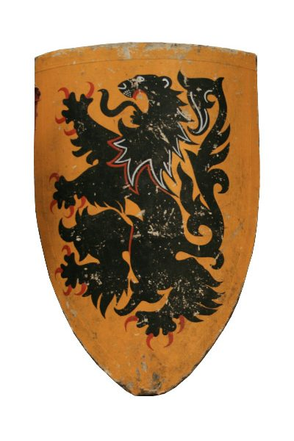The Shield card will have the design of a Heater Shield on it.
* This card will have the following information displayed on it to the player:
  + Mana Cost – **1**
  + Card Rarity – Common
  + Description – Gain temporary health.
* The draw frequency for this card is **7**
* When cast:
  + The player should have a grey bar added to the end of their health bar.
  + The players written health should feature a **+ 5** at the end that represents the additional health. This will decrease as the player takes damage.
  + When an enemy would deal damage to the player it first must go through this grey “shield” health.
  + If an enemy attack would remove all of the player remaining shield the damage should overflow into the players base health.
  + Remaining grey health at the end of an encounter should not be carried to the next encounter.

### Dodge

* The Dodge card will have the design of a target surrounded by missed arrows on it.
* This card will have the following information displayed to the player:
  + Mana Cost – **1**
  + Card Rarity – Common
  + Description – Reduce the chance of enemy hits landing until you take a hit.
* The draw frequency for this card is **7.**
* When cast:
  + 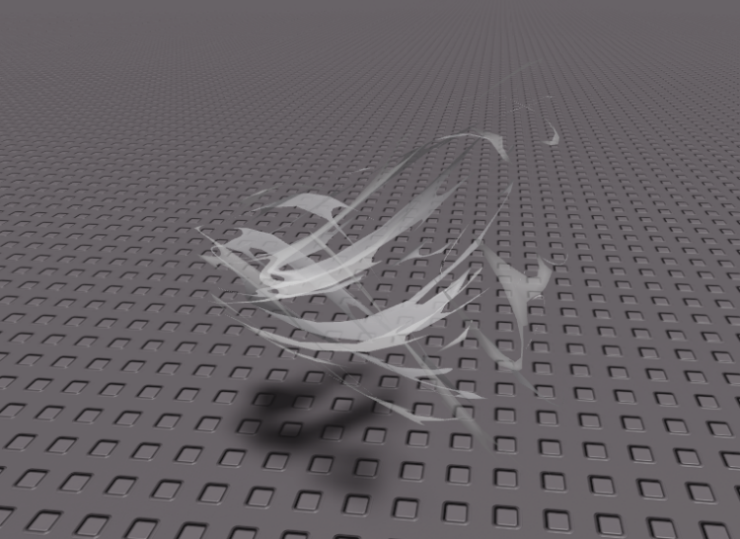A swirling wind VFX should appear around the character.
  + On subsequent enemy turns any time the player would be targeted by an enemy ability it will only go through **50%** the time
  + This effect along with the relevant VFX is removed once an ability is successfully dodged.
  + This effect does not stack, casting it whilst still under its effect grants no additional benefit.

### Shove

* The Shove card will have the design of a hand in a pushing position on it.
* This card will have the following information displayed to the player:
  + Mana Cost – **1**
  + Card Rarity – Common
  + Description – Push an enemy back a space and stun them for their next turn.
* The draw Frequency is **6**
* When cast:
  + The player should be prompted via UI pop up to “select a target.”
  + When the player hovers their mouse over an enemy they should be outlined with a white line
  + When the player presses LMB:
    - The selected enemy should be moved to the position behind them if it is unoccupied.
    - If it is occupied, they remain in place.
    - The enemy should then fall down and be unable to take its next turn.
      * The word stunned should appear underneath the enemy for the duration of the effect.
    - VFX of dust being kicked up should be played.
    - The Brute enemy should be immune to this and upon casting on this target a pop up underneath it should briefly display “immune”.

## Special Cards

**These are unique cards with special effects that the player must collect throughout the game. They vary in draw frequency.**

### Pierce

* The Pierce card will have the design of a lance being thrust forward on it.
* This card will have the following information displayed to the player:
  + Mana Cost – **2**
  + Card Rarity – Uncommon
  + Description – Slash across the front 2 enemies
* The draw Frequency is **4**
* When cast:
  + The enemy in position 1 (at the front) takes **7** damage.
  + The enemy in position 2 takes **6** damage.
  + VFX of a single horizontal slash should strike across both enemies.

### Focus

* The focus card will have the design of an eye on it.
* This card will have the following information displayed to the player:
  + Mana Cost – **1**
  + Card Rarity – Uncommon
  + Description – Negate enemy dodging.
* The draw Frequency is **4**
* When cast:
  + The next card the player would cast that would target a creature under the effects of the dodge action will hit 100% of the time.
  + VFX should be displayed on the player characters eyes that cause them to glow.

### Drag

* The Drag card will have the design of a whip on it.
* This card will have the following information displayed to the player:
  + Mana Cost – **1**
  + Card Rarity – Uncommon
  + Description – Drag an enemy towards you.
* The draw Frequency is **4**
* When cast:
  + The player should be prompted via UI pop up to “select a target.”
  + When the player hovers their mouse over an enemy they should be outlined with a white line
  + When the player presses LMB:
    - If there are any unoccupied spaces in front of the targeted enemy, it will be moved forward (e.g. from position 3 to position 1) until it either reaches position 1 or the next space it would move into is occupied.
    - When this occurs VFX of a white line should extend from the player to the enemy “lassoing” them and dragging them to them towards the player

### Frost

* The frost card will have the design of a snowflake on it.
* This card will have the following information displayed to the player:
  + Mana Cost – **2**
  + Card Rarity – Uncommon
  + Description – Freeze enemies to prevent them from moving.
* The draw Frequency is **2**
* When cast:
  + The enemies will be unable to take the move action on their next turn.
  + Snowy VFX should rain down over the enemies like a blizzard after which the ground should be covered in ice that grows up the feet of the enemy locking them in place.
  + Upon the beginning of the players next turn these VFX should dissipate

### Fireball

* The frost card will have the design of a large fireball on it.
* This card will have the following information displayed to the player:
  + Mana Cost – **3**
  + Card Rarity – Uncommon
  + Description - Fire
* The draw Frequency is **1**
* When cast:
  + All enemies should take **15** damage.
  + VFX of a fiery explosion should engulf the enemies for a few seconds.

# Husk Passives

**Depending on the Husk you receive at the start of the game different effects will apply to combat.**

## Dog

* The dog will receive the effects of the Shield card at the start of every combat encounter.

## Cat

* The cat will have access to extra mana during combat.
* On the 4th turn of combat the cat will have their maximum mana increased to 4

## Mouse

* The mouse will have the damage dealt by the Attack card reduced to **1.**
* When the Attack card is cast it will apply a stack of Poison
* Enemies with Poison stacks take **1** damage at the beginning of their turn.
* Poison stacks should be represented by a small skull and crossbones above the enemy’s head for each stack
* Upon reaching **3** stacks of Poison
  + All stacks should be removed.
  + The creature should take **8** damage.